**Java history** is interesting to know. The history of java starts from Green Team. Java team members (also known as **Green Team**), initiated a revolutionary task to develop a language for digital devices such as set-top boxes, televisions etc.

For the green team members, it was an advance concept at that time. But, it was suited for internet programming. Later, Java technology as incorporated by Netscape.

Thanks to the honorable founder of Green Team.

Our Project is based on java language on the following topic,

**RESTAURANT MANAGEMENT SYSTEM**

**INTRODUCTION**

"Restaurant Management System" is a web or executable application. This system is developed to automate day to day activity of a restaurant. Restaurant is a kind of business that serves people all over world with readymade food. This system is developed to provide service facility to restaurant and also to the customer. This restaurant management system can be used by employees in a restaurant to handle the clients, their orders and can help them easily find free tables or place orders. The services that are provided is food ordering and reservation table management by the customer through the system online, customer information management and waiter information management, menu information management and report. The restaurant menu is organized by categories (appetizers, soups, salads, entrees, sides and drinks) of menu items. Main objective build the system this is to provide ordering and reservation service by online to the customer. Each menu item has a name, price and associated recipe. A recipe for a menu item has a chef, preparation instruction sand associated ingredients. With this system online, ordering and reservation management will become easier and systematic to replace traditional system where are still using paper. To resister a meal online, the customer has to become a member first then he can access the later part of the site. this project to facilitate customer for make online ordering and reservation. The option of becoming member was only an attempt to avoid (to some extent) placing the fake bookings.

Restaurant management system is the system for manage the restaurant business. After successful login the customer can access the menu page with the items listed according to the desired time. The main point of developing this system is to help restaurant administrator manage the restaurant business and help customer for online ordering and reserve table. In proposed system user can search for a menu according to his choice i.e. according to price range and category of food and later he can order a meal.  
  
The project is developing because; many restaurants have a lot difficult to manage the business such as customer ordering and reservation table. If the customer book an order and later wants to cancel the order, he is permitted to do this only within a specific time period. By using manual customer ordering is difficult to waiter keep the correct customer information and maybe loss the customer information. The customer is also given with the facility to view the status of the order and if the order. Is ready then he can go and get it  
  
so, restaurant management system will develop to help the restaurant administrator to manage restaurant management and for customer make their online ordering and reservation table. At Management side, initially the staff member has to login, and according to his designation the privileges are set. Other than that, this project is to upgrade the manual system and make the business easily to access and systematic. If the staff member is a cook, then he is allowed to edit only the order items status, indicating which menu items he has prepared.

### Proposed restaurant management system

Nowadays, many restaurants manage their business by manual especially take customer ordering. . In traditional booking system, a customer has to go to restaurant or make a phone call in order to get his meal reserved. Today, restaurant waiter takes the customer ordering by manual system with using paper. Customer does some formal conversation like hello, hi, etc. Than he demands for today’s menu and do some discussion over menu items then he orders. It takes 5 to 10 minutes to book the order and waiter book the order on paper so there is probability of lost and duplicates customer information. Restaurant management system puts the order in a queue with specific priority according to time and quantity, and then a cook is assigned for the specific order to complete it.   
  
Besides, the restaurant waiter information also by manual system kept use paper and this is difficult for restaurant administrator to find waiter information, probability missing the paper and difficult to arrange the schedule. Initial problem is that the customer has to get connected over the phone, it would be harder if the restaurant is very popular and busy. Sometimes, waiter information and customer information is important to restaurant administrator for reference in the future. The chances of committing mistakes at the restaurant side in providing a menu list for a specific time would be more.  
  
Furthermore, restaurant side needs management in the section menu. This is the important to restaurant waiter to manage the menu. As customer won’t have the menu list with him, it would be harder for him to remember the entire list (with price as well...!) and come to a decision, i.e. customer is provided with less time to make decision. Besides this section is for customer viewer the menu that restaurant prepared and make their ordering.  
  
There might be some communication problems or sometimes language might be a barrier. As a result, the current system (manual system) is not effective and efficient to use anymore. As entire booking has to be done manually at the restaurant end, the chances of occurrence of mistakes is high as well. The current system cannot save, manage and monitor the restaurant waiter information, menu information, customer ordering information and generate report well. Even assigning orders (or some menu from the order) to a specific cook can be cumbersome if it is done parallel with the bookings of the order.

**Criteria**

* A digital computer based system which can handle the number of guests pursuing order and can calculate the ordered food.
* It intends to more user friendliness between guest and the restaurant environment.
* Online ordering may help to get in touch with the food ASAP by FREE HOME DELIVERY service.

**Purpose**

* One or more process allow customers to place order.
* Reduces time consumption.
* Allow guests to pay online or by hand to hand.
* Guests are able to know the offer peak hour immediately.

**User of the system**

Customer, administrator.

And the sub systems are-

* Admin panel
* Sub admin
* Customer offline

**Customer**  
  
This user will register to be a member to use the online system of this online restaurant management system. This online ordering divided into two type of customer; it is customer dine-in ordering and takeaway ordering. For dine in ordering, customer will view menu, make online ordering and make a reservation table. This system allows customer to place an order or allow him to cancel the book order.  But takeaway ordering, customer can view menu and online ordering without reservation table. During login, the costumer has to enter the time of delivery, and the menu items will appear accordingly. As availability of items differ from time to time. After customer make online ordering, customer can take ordering the date that customer was choose during make online ordering. Customers can search menu according to price range and the category as well, Event though, customer must confirm online ordering with restaurant three days before customer take the ordering for dine-in customer and for take-away customer will be confirm one hour before it whether by email or phone. Customer can create his new account or he can edit his personal information from the existing account.

**Administrator**

Administrator or manager is the person who will manage the entire system. he is allowed to reassign the cook according to his priority, he can edit the menu information such as its price, items available currently, etc. This type of user will also do maintenance and control the application of this system. A manager can reassign the cook for a specific order or an item. Administrator takes a responsibility to register new customer, register new waiter, register new menu into database. A manager can edit/create some or whole part of the menu record on daily basis. That is by changing the menu items, prices, description, etc.

**Module of the restaurant management system**

**Customer Registration Module**  
  
Customer registration module contains customer's information such as customer personal information and other information related to that customer. Then, all of this information recorded into database. Customers are given with a facility to change his existing password.  
  
**Customer Online Ordering and Reservation Module**  
  
Customer online ordering and reservation module provides a form that needs to be fulfilling in term of ordering food and reservation table via online.  
 **Waiter Module**  
  
Waiter module contains waiter information such as waiter personal information, task schedule and other information related to that waiter. Then, all of this information recorded into database.  
  
**Feedback Module**  
  
Based on food or everything about the restaurant, customer can send any suggestion or comment to the restaurant with feedback form. From this form, side of restaurant will know their weaknesses and strengths.  
  
**Menu Module**  
  
Menu module is food that restaurant prepared for customer. This module, customer can view the menu and make decision for order. **Feedback Module**  
  
System provides an option for generate a report. The contents of the report as the following:   
  
1. The report of customer ordering and reservation table.  
  
2. Customer's information and waiter information.  
  
3. Suggestion or comment that customer insert at feedback form  
  
4. Profit business for restaurant  
  
This system will be going to help customer and administrator in restaurant especially part of online ordering and reservation table. Most of restaurant has a problem of the ordering and reservation table. A manager can create a new entry of cook or edit the existing cook’s information from the cook’s list. The result of online ordering and reservation table will give customer easy to make ordering and reservation table online and hopefully can smoother up the job of administrator and waiter. A manager can block a particular customer before signing up. This happens when the customer’s previous history is bad, this system also produces a computerized system in defining the best solution in each ordering and reservation problem faces by customer and administrator.  
  
A restaurant management system project with user and admin accounts, graphical room booking, booking amount calculation and appropriate billing. The Restaurant Management System helps the restaurant manager to manage the restaurant more effectively and efficiently by computerizing meal ordering.

**Data Flow**

**Data Flow Main Frame**

**Main Frame**



**Data Flow Login**



No

Yes

**Data Flow Offline Order**

**Customer to cook relation (offline):**

Cooked & served

Cook received

customer order

if available

**Restaurant Apps & Extension**

**Main Frame**

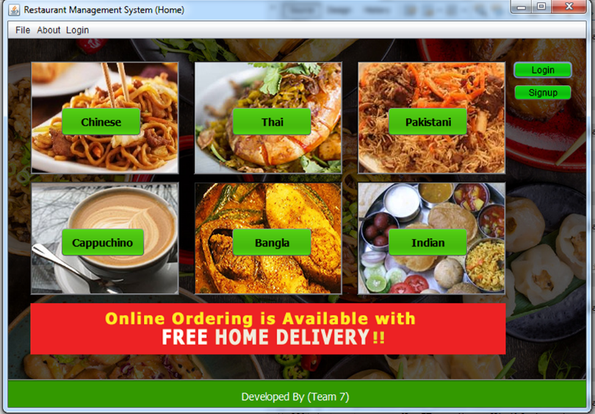

**How it works**

package javaapplication.newpackage;

import javaapplication.newpackage1.Bangla;

import javaapplication.newpackage1.Capu;

import javaapplication.newpackage1.Chinise;

import javaapplication.newpackage1.Thai;

import javaapplication.newpackage1.indian;

import javaapplication.newpackage1.login;

import javaapplication.newpackage1.pakistani;

import javaapplication.newpackage1.signup;

import javaapplication.newpackage1.thankyou;

public class NewJFrame extends javax.swing.JFrame {

/**

* Creates new form NewJFrame

*/

public NewJFrame() {

initComponents();

}

@SuppressWarnings("unchecked")

// <editor-fold defaultstate="collapsed" desc="Generated Code">

private void initComponents() {

jButton2 = new javax.swing.JButton(); jButton4 = new javax.swing.JButton(); jButton3 = new javax.swing.JButton(); jLabel5 = new javax.swing.JLabel(); jLabel6 = new javax.swing.JLabel(); jLabel2 = new javax.swing.JLabel(); jButton5 = new javax.swing.JButton();

jLabel4 = new javax.swing.JLabel(); jButton6 = new javax.swing.JButton(); jButton7 = new javax.swing.JButton();

jLabel3 = new javax.swing.JLabel(); jLabel8 = new javax.swing.JLabel(); jTextField2 = new javax.swing.JTextField();

jButton1 = new javax.swing.JButton(); jButton8 = new javax.swing.JButton(); jLabel9 = new javax.swing.JLabel(); jLabel7 = new javax.swing.JLabel(); jMenuBar1 = new javax.swing.JMenuBar(); jMenu1 = new javax.swing.JMenu();

jMenuItem9 = new javax.swing.JMenuItem(); jMenuItem1 = new javax.swing.JMenuItem();

jMenuItem2 = new javax.swing.JMenuItem(); jMenuItem3 = new javax.swing.JMenuItem();

jMenuItem4 = new javax.swing.JMenuItem(); jMenuItem5 = new javax.swing.JMenuItem();

jMenu2 = new javax.swing.JMenu(); jMenuItem8 = new javax.swing.JMenuItem();

jMenu3 = new javax.swing.JMenu(); jMenuItem6 = new javax.swing.JMenuItem();

jMenuItem7 = new javax.swing.JMenuItem();

setDefaultCloseOperation(javax.swing.WindowConstants.EXIT_ON_CLOSE);

setTitle("Restaurant Management System (Home)");

setAutoRequestFocus(false);

setPreferredSize(new java.awt.Dimension(794, 550));

getContentPane().setLayout(null);

jButton2.setBackground(new java.awt.Color(51, 153, 0)); jButton2.setFont(new java.awt.Font("Tahoma", 1, 14)); // NOI18N

jButton2.setText("Chinese"); jButton2.addActionListener(new java.awt.event.ActionListener() {

public void actionPerformed(java.awt.event.ActionEvent evt) {

jButton2ActionPerformed(evt);

}

});

getContentPane().add(jButton2);

jButton2.setBounds(70, 90, 110, 40);

jButton4.setBackground(new java.awt.Color(51, 153, 0)); jButton4.setFont(new java.awt.Font("Tahoma", 1, 14)); // NOI18N

jButton4.setText("Bangla"); jButton4.addActionListener(new java.awt.event.ActionListener() {

public void actionPerformed(java.awt.event.ActionEvent evt) {

jButton4ActionPerformed(evt);

} });

getContentPane().add(jButton4); jButton4.setBounds(300, 250, 110, 40);

jButton3.setBackground(new java.awt.Color(51, 153, 0)); jButton3.setFont(new java.awt.Font("Tahoma", 1, 14)); // NOI18N

jButton3.setText("Cappuchino"); jButton3.addActionListener(new java.awt.event.ActionListener() {

public void actionPerformed(java.awt.event.ActionEvent evt) {

jButton3ActionPerformed(evt);

} });

getContentPane().add(jButton3); jButton3.setBounds(70, 250, 115, 40);

jLabel5.setIcon(new javax.swing.ImageIcon(getClass().getResource("/javaapplication/newpackage/1.jpg"))); // NOI18N

jLabel5.setText("jLabel5");

jLabel5.setBorder(javax.swing.BorderFactory.createBevelBorder(javax.swing.border.BevelBorder.RAISED, new java.awt.Color(51, 51, 51), new java.awt.Color(102, 102, 102), null, null));

getContentPane().add(jLabel5); jLabel5.setBounds(30, 190, 200, 150);

jLabel6.setIcon(new javax.swing.ImageIcon(getClass().getResource("/javaapplication/newpackage/Screenshot (1).png"))); // NOI18N

jLabel6.setText("jLabel6");

jLabel6.setBorder(javax.swing.BorderFactory.createBevelBorder(javax.swing.border.BevelBorder.RAISED, new java.awt.Color(0, 0, 0), new java.awt.Color(51, 51, 51), null, null)); getContentPane().add(jLabel6);

jLabel6.setBounds(250, 190, 200, 150);

jLabel2.setIcon(new javax.swing.ImageIcon(getClass().getResource("/javaapplication/newpackage/chinese.jpg"))); // NOI18N

jLabel2.setText("jLabel2");

jLabel2.setBorder(javax.swing.BorderFactory.createBevelBorder(javax.swing.border.BevelBorder.RAISED, new java.awt.Color(51, 51, 51), new java.awt.Color(153, 153, 153), null, null));

getContentPane().add(jLabel2); jLabel2.setBounds(30, 30, 200, 150);

jButton5.setBackground(new java.awt.Color(51, 153, 0));

jButton5.setFont(new java.awt.Font("Tahoma", 1, 14)); // NOI18N

jButton5.setText("Thai");

jButton5.setToolTipText("");

jButton5.addActionListener(new java.awt.event.ActionListener() {

public void actionPerformed(java.awt.event.ActionEvent evt) {

jButton5ActionPerformed(evt);

} });

getContentPane().add(jButton5);

jButton5.setBounds(300, 90, 110, 40);

jLabel4.setIcon(new javax.swing.ImageIcon(getClass().getResource("/javaapplication/newpackage/khao_mok_goong_500x375.jpg"))); // NOI18N

jLabel4.setBorder(javax.swing.BorderFactory.createBevelBorder(javax.swing.border.BevelBorder.RAISED, new java.awt.Color(0, 0, 0), new java.awt.Color(153, 153, 153), null, null));

getContentPane().add(jLabel4); jLabel4.setBounds(250, 30, 200, 150);

jButton6.setBackground(new java.awt.Color(51, 153, 0));

jButton6.setFont(new java.awt.Font("Tahoma", 1, 14)); jButton6.setText("Pakistani"); jButton6.setToolTipText("");

jButton6.addActionListener(new java.awt.event.ActionListener() {

public void actionPerformed(java.awt.event.ActionEvent evt) {

jButton6ActionPerformed(evt);

} });

getContentPane().add(jButton6); jButton6.setBounds(510, 90, 110, 40);

jButton7.setBackground(new java.awt.Color(51, 153, 0)); jButton7.setFont(new java.awt.Font("Tahoma", 1, 14));

jButton7.setText("Indian"); jButton7.setToolTipText(""); jButton7.addActionListener(new java.awt.event.ActionListener() {

public void actionPerformed(java.awt.event.ActionEvent evt) {

jButton7ActionPerformed(evt);

} });

getContentPane().add(jButton7); jButton7.setBounds(510, 250, 110, 40);

jLabel3.setIcon(new javax.swing.ImageIcon("C:\\Users\\Rimon\\Desktop\\Untitled-1.gif")); // NOI18N

jLabel3.setFocusable(false); getContentPane().add(jLabel3);

jLabel3.setBounds(30, 350, 640, 70);

jLabel8.setIcon(new javax.swing.ImageIcon("C:\\Users\\Rimon\\Desktop\\images.jpg")); // NOI18N

jLabel8.setBorder(javax.swing.BorderFactory.createBevelBorder(javax.swing.border.BevelBorder.RAISED, new java.awt.Color(0, 0, 0), new java.awt.Color(153, 153, 153), null, null));

getContentPane().add(jLabel8); jLabel8.setBounds(470, 30, 200, 150);

jTextField2.setEditable(false); jTextField2.setBackground(new java.awt.Color(51, 153, 0));

jTextField2.setFont(new java.awt.Font("Tahoma", 0, 14)); jTextField2.setForeground(new java.awt.Color(255, 255, 255));

jTextField2.setText(" Developed By (Team 7)");

jTextField2.addActionListener(new java.awt.event.ActionListener() {

public void actionPerformed(java.awt.event.ActionEvent evt) {

jTextField2ActionPerformed(evt);

} });

getContentPane().add(jTextField2); jTextField2.setBounds(-20, 450, 820, 50);

jButton1.setBackground(new java.awt.Color(0, 153, 0));

jButton1.setText("Login"); jButton1.addActionListener(new java.awt.event.ActionListener() {

public void actionPerformed(java.awt.event.ActionEvent evt) {

jButton1ActionPerformed(evt);

} });

getContentPane().add(jButton1); jButton1.setBounds(680, 30, 80, 23);

jButton8.setBackground(new java.awt.Color(0, 153, 0));

jButton8.setText("Signup");

jButton8.addActionListener(new java.awt.event.ActionListener() {

public void actionPerformed(java.awt.event.ActionEvent evt) {

jButton8ActionPerformed(evt); }

}); getContentPane().add(jButton8); jButton8.setBounds(680, 60, 80, 23);

jLabel9.setIcon(new javax.swing.ImageIcon("C:\\Users\\Rimon\\Desktop\\indian-food.jpg")); // NOI18N

jLabel9.setBorder(javax.swing.BorderFactory.createBevelBorder(javax.swing.border.BevelBorder.RAISED, new java.awt.Color(0, 0, 0), new java.awt.Color(153, 153, 153), null, null));

getContentPane().add(jLabel9); jLabel9.setBounds(470, 190, 200, 150);

jLabel7.setIcon(new javax.swing.ImageIcon("C:\\Users\\Rimon\\Desktop\\585be1aa1600002400bdf2a6.jpg")); // NOI18N

jLabel7.setBorder(javax.swing.BorderFactory.createBevelBorder(javax.swing.border.BevelBorder.RAISED, new java.awt.Color(0, 0, 0), new java.awt.Color(153, 153, 153), null, null)); getContentPane().add(jLabel7);

jLabel7.setBounds(-30, -50, 830, 550);

jMenu1.setText("File"); jMenu1.setCursor(new java.awt.Cursor(java.awt.Cursor.DEFAULT_CURSOR));

jMenuItem9.setText("Home"); jMenuItem9.addActionListener(new java.awt.event.ActionListener() {

public void actionPerformed(java.awt.event.ActionEvent evt) {

jMenuItem9ActionPerformed(evt);

} });

jMenu1.add(jMenuItem9);

jMenuItem1.setText("Chinese");

jMenuItem1.addActionListener(new java.awt.event.ActionListener() {

public void actionPerformed(java.awt.event.ActionEvent evt) {

jMenuItem1ActionPerformed(evt);

} });

jMenu1.add(jMenuItem1);

jMenuItem2.setText("Thai");

jMenuItem2.addActionListener(new java.awt.event.ActionListener() {

public void actionPerformed(java.awt.event.ActionEvent evt) {

jMenuItem2ActionPerformed(evt); }

});

jMenu1.add(jMenuItem2);

jMenuItem3.setText("Drink & Matte");

jMenuItem3.addActionListener(new java.awt.event.ActionListener() {

public void actionPerformed(java.awt.event.ActionEvent evt) {

jMenuItem3ActionPerformed(evt);

} });

jMenu1.add(jMenuItem3);

jMenuItem4.setText("Bangla");

jMenuItem4.addActionListener(new java.awt.event.ActionListener() {

public void actionPerformed(java.awt.event.ActionEvent evt) {

jMenuItem4ActionPerformed(evt);

} });

jMenu1.add(jMenuItem4);

jMenuItem5.setText("Exit");

jMenuItem5.setActionCommand("EXIT_ON_CLOSE");

jMenuItem5.setFocusPainted(true);

jMenuItem5.addActionListener(new java.awt.event.ActionListener() {

public void actionPerformed(java.awt.event.ActionEvent evt) {

jMenuItem5ActionPerformed(evt);

} });

jMenu1.add(jMenuItem5); jMenuBar1.add(jMenu1);

jMenu2.setBackground(java.awt.SystemColor.window);

jMenu2.setText("About"); jMenuItem8.setText("This software is developed by Team 7");

jMenuItem8.addActionListener(new java.awt.event.ActionListener() {

public void actionPerformed(java.awt.event.ActionEvent evt) {

jMenuItem8ActionPerformed(evt);

} });

jMenu2.add(jMenuItem8);

jMenuBar1.add(jMenu2);

jMenu3.setText("Login");

jMenuItem6.setText("Login");

jMenuItem6.addActionListener(new java.awt.event.ActionListener() {

public void actionPerformed(java.awt.event.ActionEvent evt) {

jMenuItem6ActionPerformed(evt);

} });

jMenu3.add(jMenuItem6);

jMenuItem7.setText("Sign Up");

jMenuItem7.addActionListener(new java.awt.event.ActionListener() {

public void actionPerformed(java.awt.event.ActionEvent evt) {

jMenuItem7ActionPerformed(evt);

} });

jMenu3.add(jMenuItem7);

jMenuBar1.add(jMenu3);

setJMenuBar(jMenuBar1);

pack();

}// </editor-fold>

private void jButton2ActionPerformed(java.awt.event.ActionEvent evt) {

// TODO add your handling code here:

Chinise obj=new Chinise();

obj.setVisible(true);

}

private void jMenuItem1ActionPerformed(java.awt.event.ActionEvent evt) {

Chinise obj=new Chinise(); obj.setVisible(true);

// TODO add your handling code here:

}

private void jMenuItem5ActionPerformed(java.awt.event.ActionEvent evt) {

this.dispose(); // TODO add your handling code here:

}

private void jButton3ActionPerformed(java.awt.event.ActionEvent evt) {

Capu obj=new Capu(); obj.setVisible(true);

// TODO add your handling code here:

}

private void jTextField2ActionPerformed(java.awt.event.ActionEvent evt) {

// TODO add your handling code here:

}

private void jMenuItem8ActionPerformed(java.awt.event.ActionEvent evt) {

// TODO add your handling code here:

}

private void jButton4ActionPerformed(java.awt.event.ActionEvent evt) {

Bangla obj=new Bangla(); obj.setVisible(true);

// TODO add your handling code here:

}

private void jMenuItem2ActionPerformed(java.awt.event.ActionEvent evt) {

Thai obj=new Thai();

obj.setVisible(true);

// TODO add your handling code here:

}

private void jMenuItem3ActionPerformed(java.awt.event.ActionEvent evt) {

Capu obj=new Capu(); obj.setVisible(true);

// TODO add your handling code here:

}

private void jMenuItem4ActionPerformed(java.awt.event.ActionEvent evt) {

Bangla obj=new Bangla(); obj.setVisible(true);

// TODO add your handling code here:

}

private void jMenuItem6ActionPerformed(java.awt.event.ActionEvent evt) {

login obj=new login(); obj.setVisible(true);

this.dispose();// TODO add your handling code here:

} private void jMenuItem7ActionPerformed(java.awt.event.ActionEvent evt) {

signup obj=new signup(); obj.setVisible(true);

this.dispose();// TODO add your handling code here:

}

private void jMenuItem9ActionPerformed(java.awt.event.ActionEvent evt) {

new NewJFrame().setVisible(true); this.dispose();

}

private void jButton5ActionPerformed(java.awt.event.ActionEvent evt) {

new Thai().setVisible(true); }

private void jButton6ActionPerformed(java.awt.event.ActionEvent evt) {

new pakistani().setVisible(true); }

private void jButton7ActionPerformed(java.awt.event.ActionEvent evt) {

new indian().setVisible(true); // TODO add your handling code here:

} private void jButton1ActionPerformed(java.awt.event.ActionEvent evt) {

new login().setVisible(true);this.dispose();

}

private void jButton8ActionPerformed(java.awt.event.ActionEvent evt) {

new signup().setVisible(true);

this.dispose(); // TODO add your handling code here:

} public static void main(String args[]) {

try {

for (javax.swing.UIManager.LookAndFeelInfo info : javax.swing.UIManager.getInstalledLookAndFeels()) {

if ("Nimbus".equals(info.getName())) {

javax.swing.UIManager.setLookAndFeel(info.getClassName());

break;

}

}

} catch (ClassNotFoundException ex) {

java.util.logging.Logger.getLogger(NewJFrame.class.getName()).log(java.util.logging.Level.SEVERE, null, ex);

} catch (InstantiationException ex) {

java.util.logging.Logger.getLogger(NewJFrame.class.getName()).log(java.util.logging.Level.SEVERE, null, ex);

} catch (IllegalAccessException ex) {

java.util.logging.Logger.getLogger(NewJFrame.class.getName()).log(java.util.logging.Level.SEVERE, null, ex);

} catch (javax.swing.UnsupportedLookAndFeelException ex) {

java.util.logging.Logger.getLogger(NewJFrame.class.getName()).log(java.util.logging.Level.SEVERE, null, ex);

} /* Create and display the form */

java.awt.EventQueue.invokeLater(new Runnable() {

public void run() {

new NewJFrame().setVisible(true);

} }); }

// Variables declaration - do not modify

private javax.swing.JButton jButton1;

private javax.swing.JButton jButton2;

private javax.swing.JButton jButton3;

private javax.swing.JButton jButton4;

private javax.swing.JButton jButton5;

private javax.swing.JButton jButton6;

private javax.swing.JButton jButton7;

private javax.swing.JButton jButton8;

private javax.swing.JLabel jLabel2;

private javax.swing.JLabel jLabel3;

private javax.swing.JLabel jLabel4;

private javax.swing.JLabel jLabel5;

private javax.swing.JLabel jLabel6;

private javax.swing.JLabel jLabel7;

private javax.swing.JLabel jLabel8;

private javax.swing.JLabel jLabel9;

private javax.swing.JMenu jMenu1;

private javax.swing.JMenu jMenu2;

private javax.swing.JMenu jMenu3;

private javax.swing.JMenuBar jMenuBar1;

private javax.swing.JMenuItem jMenuItem1;

private javax.swing.JMenuItem jMenuItem2;

private javax.swing.JMenuItem jMenuItem3;

private javax.swing.JMenuItem jMenuItem4;

private javax.swing.JMenuItem jMenuItem5;

private javax.swing.JMenuItem jMenuItem6;

private javax.swing.JMenuItem jMenuItem7;

private javax.swing.JMenuItem jMenuItem8;

private javax.swing.JMenuItem jMenuItem9;

private javax.swing.JTextField jTextField2;

}

**Main Frame with Navigation bar**

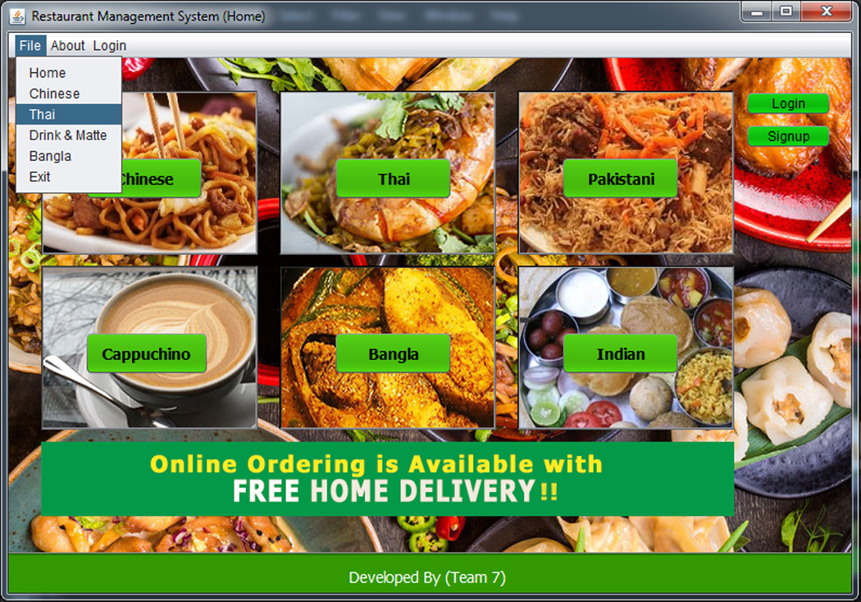

**Code for Navigation Bar**

private void jMenuItem9ActionPerformed(java.awt.event.ActionEvent evt) {

new NewJFrame().setVisible(true); this.dispose(); }

private void jButton5ActionPerformed(java.awt.event.ActionEvent evt) {

new Thai().setVisible(true); } private void jButton6ActionPerformed(java.awt.event.ActionEvent evt) {

new pakistani().setVisible(true); }

private void jButton7ActionPerformed(java.awt.event.ActionEvent evt) {

new indian().setVisible(true); // TODO add your handling code here:

} private void jButton1ActionPerformed(java.awt.event.ActionEvent evt) { new login().setVisible(true); this.dispose(); }

private void jButton8ActionPerformed(java.awt.event.ActionEvent evt) {

new signup().setVisible(true);

this.dispose(); }

**Available food menu (On Click)**

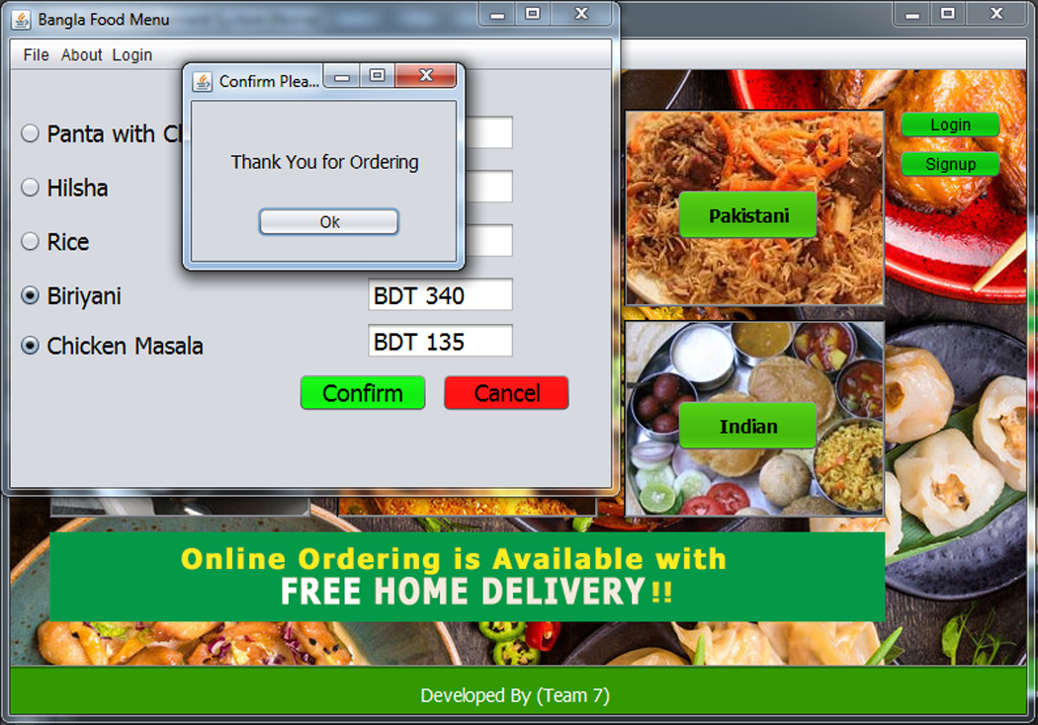

**Code Segment**

**Radio Button**

private void jRadioButton3ActionPerformed(java.awt.event.ActionEvent evt) {

// TODO add your handling code here:

}

**Confirm Button**

private void jButton2ActionPerformed(java.awt.event.ActionEvent evt) {

new thankyou().setVisible(true);

}

**Thank You Menu after Confirmation**

private void jButton1ActionPerformed(java.awt.event.ActionEvent evt) {

this.dispose(); }

**Cancel to go Main Page**

private void jButton1ActionPerformed(java.awt.event.ActionEvent evt) {

this.dispose(); }

**Login Form**

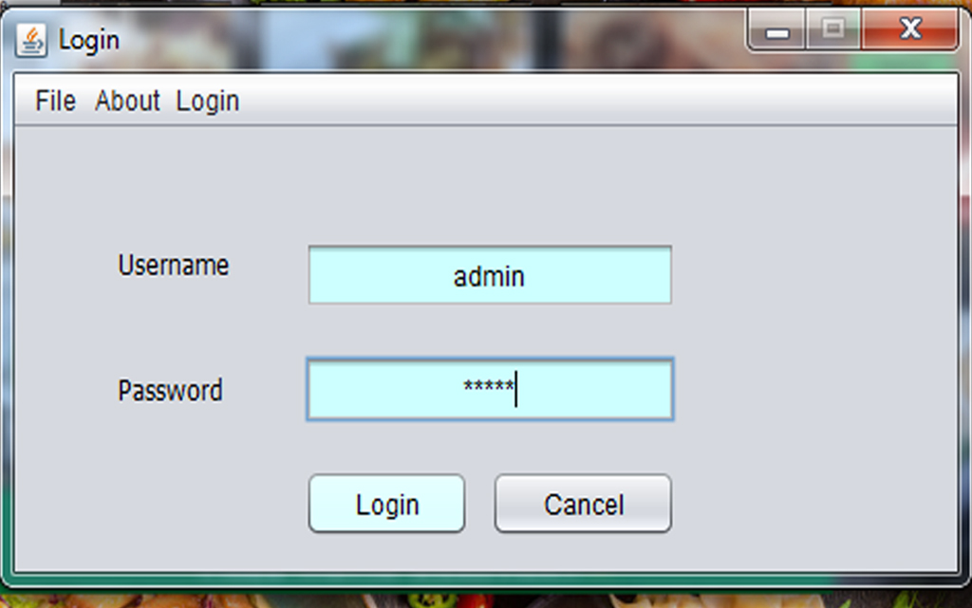

**Code Segment**

package javaapplication.newpackage1;

import javaapplication.newpackage.NewJFrame;

public class login extends javax.swing.JFrame {

//Creates new form login

public login() {

initComponents();

}@SuppressWarnings("unchecked")

// <editor-fold defaultstate="collapsed" desc="Generated Code">

private void initComponents() {

popupMenu1 = new java.awt.PopupMenu();jPopupMenu1 = new javax.swing.JPopupMenu();jPanel1 = new javax.swing.JPanel();

jButton1 = new javax.swing.JButton();jTextField5 = new javax.swing.JTextField();jPasswordField1 = new javax.swing.JPasswordField();jButton2 = new javax.swing.JButton();jLabel1 = new javax.swing.JLabel();

jLabel2 = new javax.swing.JLabel();jMenuBar1 = new javax.swing.JMenuBar();jMenu1 = new javax.swing.JMenu();

jMenuItem9 = new javax.swing.JMenuItem();jMenuItem1 = new javax.swing.JMenuItem();jMenuItem2 = new javax.swing.JMenuItem();jMenuItem3 = new javax.swing.JMenuItem();jMenuItem4 = new javax.swing.JMenuItem();jMenuItem5 = new javax.swing.JMenuItem();jMenu2 = new javax.swing.JMenu();jMenuItem8 = new javax.swing.JMenuItem();jMenu3 = new javax.swing.JMenu();jMenuItem6 = new javax.swing.JMenuItem();

jMenuItem7 = new javax.swing.JMenuItem();popupMenu1.setLabel("popupMenu1");

setDefaultCloseOperation(javax.swing.WindowConstants.DO_NOTHING_ON_CLOSE);

setTitle("Login");

setAlwaysOnTop(true);

setPreferredSize(new java.awt.Dimension(462, 246));

setResizable(false);

getContentPane().setLayout(null);

jPanel1.setForeground(new java.awt.Color(204, 102, 255));

jPanel1.setLayout(new org.netbeans.lib.awtextra.AbsoluteLayout());

jButton1.setBackground(new java.awt.Color(204, 255, 255));

jButton1.setText("Login");jButton1.setBorder(null);

jButton1.addActionListener(new java.awt.event.ActionListener() {

public void actionPerformed(java.awt.event.ActionEvent evt) {

jButton1ActionPerformed(evt);

}});

jPanel1.add(jButton1, new org.netbeans.lib.awtextra.AbsoluteConstraints(100, 110, 80, 30));

jTextField5.setBackground(new java.awt.Color(204, 255, 255));

jTextField5.setHorizontalAlignment(javax.swing.JTextField.CENTER);

jTextField5.addActionListener(new java.awt.event.ActionListener() {

public void actionPerformed(java.awt.event.ActionEvent evt) {

jTextField5ActionPerformed(evt);}

});

jPanel1.add(jTextField5, new org.netbeans.lib.awtextra.AbsoluteConstraints(100, 10, 180, 30));

jPasswordField1.setBackground(new java.awt.Color(204, 255, 255));

jPasswordField1.setHorizontalAlignment(javax.swing.JTextField.CENTER);

jPanel1.add(jPasswordField1, new org.netbeans.lib.awtextra.AbsoluteConstraints(100, 60, 180, 30));

jButton2.setText("Cancel");

jButton2.addActionListener(new java.awt.event.ActionListener() {

public void actionPerformed(java.awt.event.ActionEvent evt) {

jButton2ActionPerformed(evt); } });

jPanel1.add(jButton2, new org.netbeans.lib.awtextra.AbsoluteConstraints(190, 110, 90, 30));

jLabel1.setFont(new java.awt.Font("Tahoma", 0, 12)); // NOI18N

jLabel1.setText("Password");

jPanel1.add(jLabel1, new org.netbeans.lib.awtextra.AbsoluteConstraints(10, 60, 80, 30));

jLabel2.setFont(new java.awt.Font("Tahoma", 0, 12)); // NOI18N

jLabel2.setText("Username");

jPanel1.add(jLabel2, new org.netbeans.lib.awtextra.AbsoluteConstraints(10, 10, 80, 20));

getContentPane().add(jPanel1);

jPanel1.setBounds(40, 40, 330, 160);

jMenu1.setText("File");

jMenu1.setCursor(new java.awt.Cursor(java.awt.Cursor.DEFAULT_CURSOR));

jMenuItem9.setText("Home");

jMenuItem9.addActionListener(new java.awt.event.ActionListener() {

public void actionPerformed(java.awt.event.ActionEvent evt) {

jMenuItem9ActionPerformed(evt); }

}); jMenu1.add(jMenuItem9); jMenuItem1.setText("Chinese");

jMenuItem1.addActionListener(new java.awt.event.ActionListener() {

public void actionPerformed(java.awt.event.ActionEvent evt) {

jMenuItem1ActionPerformed(evt); }

}); jMenu1.add(jMenuItem1);

jMenuItem2.setText("Thai"); jMenuItem2.addActionListener(new java.awt.event.ActionListener() {

public void actionPerformed(java.awt.event.ActionEvent evt) {

jMenuItem2ActionPerformed(evt); }

}); jMenu1.add(jMenuItem2);

jMenuItem3.setText("Drink & Matte");

jMenuItem3.addActionListener(new java.awt.event.ActionListener() {

public void actionPerformed(java.awt.event.ActionEvent evt) {

jMenuItem3ActionPerformed(evt); }

});

jMenu1.add(jMenuItem3);

jMenuItem4.setText("Bangla");

jMenuItem4.addActionListener(new java.awt.event.ActionListener() {

public void actionPerformed(java.awt.event.ActionEvent evt) {

jMenuItem4ActionPerformed(evt); }

}); jMenu1.add(jMenuItem4);

jMenuItem5.setText("Exit");

jMenuItem5.setActionCommand("EXIT_ON_CLOSE");

jMenuItem5.setFocusPainted(true);

jMenuItem5.addActionListener(new java.awt.event.ActionListener() {

public void actionPerformed(java.awt.event.ActionEvent evt) {

jMenuItem5ActionPerformed(evt); }

}); jMenu1.add(jMenuItem5);

jMenuBar1.add(jMenu1);

jMenu2.setBackground(java.awt.SystemColor.window);

jMenu2.setText("About");

jMenuItem8.setText("This software is developed by Team 7");

jMenuItem8.addActionListener(new java.awt.event.ActionListener() {

public void actionPerformed(java.awt.event.ActionEvent evt) {

jMenuItem8ActionPerformed(evt); }

}); jMenu2.add(jMenuItem8);

jMenuBar1.add(jMenu2);

jMenu3.setText("Login");

jMenuItem6.setText("Login");

jMenuItem6.addActionListener(new java.awt.event.ActionListener() {

public void actionPerformed(java.awt.event.ActionEvent evt) {

jMenuItem6ActionPerformed(evt); }

}); jMenu3.add(jMenuItem6);

jMenuItem7.setText("Sign Up");

jMenuItem7.addActionListener(new java.awt.event.ActionListener() {

public void actionPerformed(java.awt.event.ActionEvent evt) {

jMenuItem7ActionPerformed(evt); });

jMenu3.add(jMenuItem7); jMenuBar1.add(jMenu3); setJMenuBar(jMenuBar1);

pack();

}// </editor-fold>

private void jButton2ActionPerformed(java.awt.event.ActionEvent evt) {

NewJFrame obj=new NewJFrame();

obj.setVisible(true);

this.dispose();

// TODO add your handling code here:

}

private void jTextField5ActionPerformed(java.awt.event.ActionEvent evt) {

// TODO add your handling code here:

}

private void jButton1ActionPerformed(java.awt.event.ActionEvent evt) {

String user=jTextField5.getText();

String pwd= new String(jPasswordField1.getPassword());

if(user.equals("admin") && pwd.equals("admin"))

{ this.dispose();

new loginsuccess().setVisible(true);

}// TODO add your handling code here:

}

private void jMenuItem9ActionPerformed(java.awt.event.ActionEvent evt) {

new NewJFrame().setVisible(true);

this.dispose(); }

private void jMenuItem1ActionPerformed(java.awt.event.ActionEvent evt) {

Chinise obj=new Chinise();

obj.setVisible(true);

// TODO add your handling code here:

}

private void jMenuItem2ActionPerformed(java.awt.event.ActionEvent evt) {

Thai obj=new Thai(); obj.setVisible(true);

// TODO add your handling code here:

}

private void jMenuItem3ActionPerformed(java.awt.event.ActionEvent evt) {

Capu obj=new Capu(); obj.setVisible(true);

// TODO add your handling code here:

} private void jMenuItem4ActionPerformed(java.awt.event.ActionEvent evt) {

Bangla obj=new Bangla(); obj.setVisible(true);

// TODO add your handling code here:

}

private void jMenuItem5ActionPerformed(java.awt.event.ActionEvent evt) {

this.dispose(); // TODO add your handling code here:

} private void jMenuItem8ActionPerformed(java.awt.event.ActionEvent evt) {

// TODO add your handling code here:

} private void jMenuItem6ActionPerformed(java.awt.event.ActionEvent evt) {

login obj=new login(); obj.setVisible(true);

this.dispose();// TODO add your handling code here:

} private void jMenuItem7ActionPerformed(java.awt.event.ActionEvent evt) {

signup obj=new signup(); obj.setVisible(true);

this.dispose(); // TODO add your handling code here:

} /**

* @param args the command line arguments

*/ public static void main(String args[]) {

try {

for (javax.swing.UIManager.LookAndFeelInfo info : javax.swing.UIManager.getInstalledLookAndFeels()) {

if ("Nimbus".equals(info.getName())) {

javax.swing.UIManager.setLookAndFeel(info.getClassName());

break;

} }

} catch (ClassNotFoundException ex) {

java.util.logging.Logger.getLogger(login.class.getName()).log(java.util.logging.Level.SEVERE, null, ex);

} catch (InstantiationException ex) {

java.util.logging.Logger.getLogger(login.class.getName()).log(java.util.logging.Level.SEVERE, null, ex);

} catch (IllegalAccessException ex) {

java.util.logging.Logger.getLogger(login.class.getName()).log(java.util.logging.Level.SEVERE, null, ex);

} catch (javax.swing.UnsupportedLookAndFeelException ex) {

java.util.logging.Logger.getLogger(login.class.getName()).log(java.util.logging.Level.SEVERE, null, ex);

} //</editor-fold>

/* Create and display the form */

java.awt.EventQueue.invokeLater(new Runnable() {

public void run() {

new login().setVisible(true);

} });

}

// Variables declaration - do not modify

private javax.swing.JButton jButton1; private javax.swing.JButton jButton2;

private javax.swing.JLabel jLabel1; private javax.swing.JLabel jLabel2;

private javax.swing.JMenu jMenu1; private javax.swing.JMenu jMenu2;

private javax.swing.JMenu jMenu3; private javax.swing.JMenuBar jMenuBar1;

private javax.swing.JMenuItem jMenuItem1;

private javax.swing.JMenuItem jMenuItem2;

private javax.swing.JMenuItem jMenuItem3;

private javax.swing.JMenuItem jMenuItem4;

private javax.swing.JMenuItem jMenuItem5;

private javax.swing.JMenuItem jMenuItem6;

private javax.swing.JMenuItem jMenuItem7;

private javax.swing.JMenuItem jMenuItem8;

private javax.swing.JMenuItem jMenuItem9;

private javax.swing.JPanel jPanel1;

private javax.swing.JPasswordField jPasswordField1;

private javax.swing.JPopupMenu jPopupMenu1;

private javax.swing.JTextField jTextField5;

private java.awt.PopupMenu popupMenu1; }

**Sign Up Page on Registration**

To register for a new account into the following restaurant the user must have to create a new account by using the registration form. The user must fill up all the blank boxes and must check the checkbox with a valid password that he/she can remember. And again confirm the password previously given. All the kind of information if happens then user must submit the form to save it in the database. After saving the information user can login to the management system to order food anywhere anytime if available condition applied.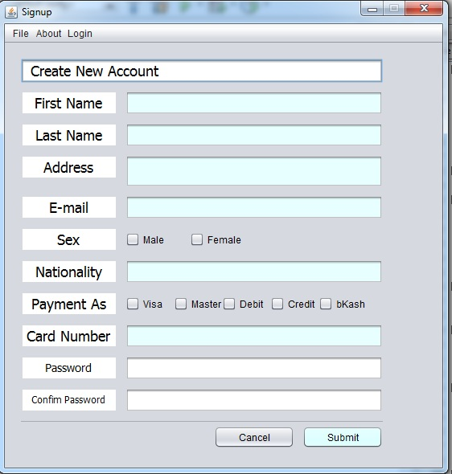

**Code Segment**

package javaapplication.newpackage1;

import javaapplication.newpackage.NewJFrame;

public class signup extends javax.swing.JFrame {

/** * Creates new form signup */

public signup() { initComponents(); }

@SuppressWarnings("unchecked")

// <editor-fold defaultstate="collapsed" desc="Generated Code">

private void initComponents() {

jPanel1 = new javax.swing.JPanel(); Jlabel = new javax.swing.JTextField(); jTextField6 = new javax.swing.JTextField(); jTextField1 = new javax.swing.JTextField(); jTextField5 = new javax.swing.JTextField(); jSeparator1 = new javax.swing.JSeparator(); jTextField7 = new javax.swing.JTextField(); jTextField8 = new javax.swing.JTextField(); jCheckBox1 = new javax.swing.JCheckBox(); jCheckBox2 = new javax.swing.JCheckBox();

jTextField9 = new javax.swing.JTextField(); jTextField10 = new javax.swing.JTextField(); jTextField11 = new javax.swing.JTextField(); jTextField12 = new javax.swing.JTextField(); jTextField13 = new javax.swing.JTextField();

jCheckBox3 = new javax.swing.JCheckBox(); jCheckBox4 = new javax.swing.JCheckBox();

jCheckBox5 = new javax.swing.JCheckBox(); jCheckBox6 = new javax.swing.JCheckBox();

jCheckBox7 = new javax.swing.JCheckBox(); jTextField14 = new javax.swing.JTextField();

jTextField15 = new javax.swing.JTextField(); jTextField16 = new javax.swing.JTextField();

jTextField17 = new javax.swing.JTextField(); jPasswordField1 = new javax.swing.JPasswordField();

jTextField18 = new javax.swing.JTextField(); jTextField19 = new javax.swing.JTextField();

jPasswordField2 = new javax.swing.JPasswordField(); jButton2 = new javax.swing.JButton();

jButton1 = new javax.swing.JButton(); jMenuBar1 = new javax.swing.JMenuBar();

jMenu1 = new javax.swing.JMenu(); jMenuItem9 = new javax.swing.JMenuItem();

jMenuItem1 = new javax.swing.JMenuItem(); jMenuItem2 = new javax.swing.JMenuItem();

jMenuItem3 = new javax.swing.JMenuItem(); jMenuItem4 = new javax.swing.JMenuItem();

jMenuItem5 = new javax.swing.JMenuItem(); jMenu2 = new javax.swing.JMenu();

jMenuItem8 = new javax.swing.JMenuItem(); jMenu3 = new javax.swing.JMenu();

jMenuItem6 = new javax.swing.JMenuItem(); jMenuItem7 = new javax.swing.JMenuItem();

setDefaultCloseOperation(javax.swing.WindowConstants.DO_NOTHING_ON_CLOSE);

setTitle("Signup"); setForeground(java.awt.Color.lightGray);

setPreferredSize(new java.awt.Dimension(550, 580)); setResizable(false);

getContentPane().setLayout(null); jPanel1.setLayout(new org.netbeans.lib.awtextra.AbsoluteLayout());

Jlabel.setEditable(false); Jlabel.setBackground(java.awt.SystemColor.controlLtHighlight);

Jlabel.setFont(new java.awt.Font("Tahoma", 0, 18)); // NOI18N

Jlabel.setHorizontalAlignment(javax.swing.JTextField.CENTER);

Jlabel.setText("First Name"); Jlabel.setBorder(null);

Jlabel.setCursor(new java.awt.Cursor(java.awt.Cursor.TEXT_CURSOR));

Jlabel.setHighlighter(null); Jlabel.addActionListener(new java.awt.event.ActionListener() {

public void actionPerformed(java.awt.event.ActionEvent evt) {

JlabelActionPerformed(evt); } });

jPanel1.add(Jlabel, new org.netbeans.lib.awtextra.AbsoluteConstraints(20, 60, 120, 30));

jTextField6.setBackground(new java.awt.Color(231, 255, 255)); jTextField6.setHorizontalAlignment(javax.swing.JTextField.CENTER); jTextField6.addActionListener(new java.awt.event.ActionListener() { public void actionPerformed(java.awt.event.ActionEvent evt) {

jTextField6ActionPerformed(evt); } });

jPanel1.add(jTextField6, new org.netbeans.lib.awtextra.AbsoluteConstraints(150, 60, 320, 30));

jTextField1.setEditable(false); jTextField1.setFont(new java.awt.Font("Tahoma", 0, 18)); // NOI18N

jTextField1.setHorizontalAlignment(javax.swing.JTextField.LEFT); jTextField1.setText(" Create New Account");

jTextField1.setAutoscrolls(false); jTextField1.addActionListener(new java.awt.event.ActionListener() {

public void actionPerformed(java.awt.event.ActionEvent evt) { jTextField1ActionPerformed(evt);

} }); jPanel1.add(jTextField1, new org.netbeans.lib.awtextra.AbsoluteConstraints(20, 20, 450, 30));

jTextField5.setBackground(new java.awt.Color(231, 255, 255)); jTextField5.setHorizontalAlignment(javax.swing.JTextField.CENTER); jTextField5.addActionListener(new java.awt.event.ActionListener() { public void actionPerformed(java.awt.event.ActionEvent evt) {

jTextField5ActionPerformed(evt); } });

jPanel1.add(jTextField5, new org.netbeans.lib.awtextra.AbsoluteConstraints(150, 270, 320, 30));

jSeparator1.setBackground(new java.awt.Color(204, 255, 255)); jPanel1.add(jSeparator1, new org.netbeans.lib.awtextra.AbsoluteConstraints(20, 470, 450, 20));

jTextField7.setEditable(false); jTextField7.setBackground(java.awt.SystemColor.controlLtHighlight);

jTextField7.setFont(new java.awt.Font("Tahoma", 0, 18)); jTextField7.setHorizontalAlignment(javax.swing.JTextField.CENTER); jTextField7.setText("Last Name");

jTextField7.setBorder(null); jTextField7.setCursor(new java.awt.Cursor(java.awt.Cursor.TEXT_CURSOR));

jTextField7.addActionListener(new java.awt.event.ActionListener() { public void actionPerformed(java.awt.event.ActionEvent evt) { jTextField7ActionPerformed(evt);

} }); jPanel1.add(jTextField7, new org.netbeans.lib.awtextra.AbsoluteConstraints(20, 100, 120, 30));

jTextField8.setBackground(new java.awt.Color(231, 255, 255)); jTextField8.setHorizontalAlignment(javax.swing.JTextField.CENTER); jTextField8.addActionListener(new java.awt.event.ActionListener() { public void actionPerformed(java.awt.event.ActionEvent evt) {

jTextField8ActionPerformed(evt); } });

jPanel1.add(jTextField8, new org.netbeans.lib.awtextra.AbsoluteConstraints(150, 350, 320, 30));

jCheckBox1.setBackground(new java.awt.Color(231, 255, 255)); jCheckBox1.setText("Female");

jCheckBox1.addActionListener(new java.awt.event.ActionListener() { public void actionPerformed(java.awt.event.ActionEvent evt) { jCheckBox1ActionPerformed(evt);

} }); jPanel1.add(jCheckBox1, new org.netbeans.lib.awtextra.AbsoluteConstraints(230, 230, 100, 30));

jCheckBox2.setBackground(new java.awt.Color(231, 255, 255)); jCheckBox2.setText("Male");

jPanel1.add(jCheckBox2, new org.netbeans.lib.awtextra.AbsoluteConstraints(150, 230, 80, 30));

jTextField9.setEditable(false); jTextField9.setBackground(java.awt.SystemColor.controlLtHighlight);

jTextField9.setFont(new java.awt.Font("Tahoma", 0, 18)); jTextField9.setHorizontalAlignment(javax.swing.JTextField.CENTER); jTextField9.setText("E-mail");

jTextField9.setBorder(null); jTextField9.setCursor(new java.awt.Cursor(java.awt.Cursor.TEXT_CURSOR));

jTextField9.addActionListener(new java.awt.event.ActionListener() { public void actionPerformed(java.awt.event.ActionEvent evt) { jTextField9ActionPerformed(evt);

} }); jPanel1.add(jTextField9, new org.netbeans.lib.awtextra.AbsoluteConstraints(20, 190, 120, 30));

jTextField10.setEditable(false); jTextField10.setBackground(java.awt.SystemColor.controlLtHighlight);

jTextField10.setFont(new java.awt.Font("Tahoma", 0, 18));

jTextField10.setHorizontalAlignment(javax.swing.JTextField.CENTER);

jTextField10.setText("Sex"); jTextField10.setBorder(null); jTextField10.setCursor(new java.awt.Cursor(java.awt.Cursor.TEXT_CURSOR)); jTextField10.addActionListener(new java.awt.event.ActionListener() {

public void actionPerformed(java.awt.event.ActionEvent evt) {

jTextField10ActionPerformed(evt); }

}); jPanel1.add(jTextField10, new org.netbeans.lib.awtextra.AbsoluteConstraints(20, 230, 120, 30));

jTextField11.setEditable(false); jTextField11.setBackground(java.awt.SystemColor.controlLtHighlight);

jTextField11.setFont(new java.awt.Font("Tahoma", 0, 12)); // NOI18N

jTextField11.setHorizontalAlignment(javax.swing.JTextField.CENTER);

jTextField11.setText("Confim Password"); jTextField11.setBorder(null);

jTextField11.setCursor(new java.awt.Cursor(java.awt.Cursor.TEXT_CURSOR));

jTextField11.addActionListener(new java.awt.event.ActionListener() {

public void actionPerformed(java.awt.event.ActionEvent evt) {

jTextField11ActionPerformed(evt); } });

jPanel1.add(jTextField11, new org.netbeans.lib.awtextra.AbsoluteConstraints(20, 430, 120, 30));

jTextField12.setBackground(new java.awt.Color(231, 255, 255));

jTextField12.setHorizontalAlignment(javax.swing.JTextField.CENTER); jTextField12.addActionListener(new java.awt.event.ActionListener() { public void actionPerformed(java.awt.event.ActionEvent evt) {

jTextField12ActionPerformed(evt); }

}); jPanel1.add(jTextField12, new org.netbeans.lib.awtextra.AbsoluteConstraints(150, 140, 320, 40));

jTextField13.setEditable(false); jTextField13.setBackground(java.awt.SystemColor.controlLtHighlight);

jTextField13.setFont(new java.awt.Font("Tahoma", 0, 18)); // NOI18N

jTextField13.setHorizontalAlignment(javax.swing.JTextField.CENTER);

jTextField13.setText("Nationality"); jTextField13.setBorder(null); jTextField13.setCursor(new java.awt.Cursor(java.awt.Cursor.TEXT_CURSOR)); jTextField13.addActionListener(new java.awt.event.ActionListener() {

public void actionPerformed(java.awt.event.ActionEvent evt) {

jTextField13ActionPerformed(evt); }

}); jPanel1.add(jTextField13, new org.netbeans.lib.awtextra.AbsoluteConstraints(20, 270, 120, 30));

jCheckBox3.setBackground(new java.awt.Color(231, 255, 255));

jCheckBox3.setText("Visa"); jPanel1.add(jCheckBox3, new org.netbeans.lib.awtextra.AbsoluteConstraints(150, 310, 60, 30));

jCheckBox4.setBackground(new java.awt.Color(231, 255, 255));

jCheckBox4.setText("Master"); jCheckBox4.addActionListener(new java.awt.event.ActionListener() {

public void actionPerformed(java.awt.event.ActionEvent evt) {

jCheckBox4ActionPerformed(evt); } });

jPanel1.add(jCheckBox4, new org.netbeans.lib.awtextra.AbsoluteConstraints(210, 310, 60, 30));

jCheckBox5.setBackground(new java.awt.Color(231, 255, 255));

jCheckBox5.setText("bKash"); jCheckBox5.addActionListener(new java.awt.event.ActionListener() {

public void actionPerformed(java.awt.event.ActionEvent evt) {

jCheckBox5ActionPerformed(evt); }

}); jPanel1.add(jCheckBox5, new org.netbeans.lib.awtextra.AbsoluteConstraints(390, 310, 80, 30));

jCheckBox6.setBackground(new java.awt.Color(231, 255, 255)); jCheckBox6.setText("Debit");

jPanel1.add(jCheckBox6, new org.netbeans.lib.awtextra.AbsoluteConstraints(270, 310, 60, 30));

jCheckBox7.setBackground(new java.awt.Color(231, 255, 255));

jCheckBox7.setText("Credit"); jCheckBox7.addActionListener(new java.awt.event.ActionListener() {

public void actionPerformed(java.awt.event.ActionEvent evt) {

jCheckBox7ActionPerformed(evt); }

}); jPanel1.add(jCheckBox7, new org.netbeans.lib.awtextra.AbsoluteConstraints(330, 310, 70, 30));

jTextField14.setBackground(new java.awt.Color(231, 255, 255)); jTextField14.setHorizontalAlignment(javax.swing.JTextField.CENTER);

jTextField14.setCursor(new java.awt.Cursor(java.awt.Cursor.TEXT_CURSOR));

jTextField14.addActionListener(new java.awt.event.ActionListener() { public void actionPerformed(java.awt.event.ActionEvent evt) { jTextField14ActionPerformed(evt); }

}); jPanel1.add(jTextField14, new org.netbeans.lib.awtextra.AbsoluteConstraints(150, 190, 320, 30));

jTextField15.setEditable(false); jTextField15.setBackground(java.awt.SystemColor.controlLtHighlight);

jTextField15.setFont(new java.awt.Font("Tahoma", 0, 18)); jTextField15.setHorizontalAlignment(javax.swing.JTextField.CENTER);

jTextField15.setText("Payment As"); jTextField15.setBorder(null);

jTextField15.setCursor(new java.awt.Cursor(java.awt.Cursor.TEXT_CURSOR)); jTextField15.addActionListener(new java.awt.event.ActionListener() { public void actionPerformed(java.awt.event.ActionEvent evt) {

jTextField15ActionPerformed(evt); }

}); jPanel1.add(jTextField15, new org.netbeans.lib.awtextra.AbsoluteConstraints(20, 310, 120, 30));

jTextField16.setEditable(false); jTextField16.setBackground(java.awt.SystemColor.controlLtHighlight);

jTextField16.setFont(new java.awt.Font("Tahoma", 0, 18)); jTextField16.setHorizontalAlignment(javax.swing.JTextField.CENTER); jTextField16.setText("Address");

jTextField16.setBorder(null); jTextField16.setCursor(new java.awt.Cursor(java.awt.Cursor.TEXT_CURSOR));

jTextField16.addActionListener(new java.awt.event.ActionListener() { public void actionPerformed(java.awt.event.ActionEvent evt) { jTextField16ActionPerformed(evt);

} });

jPanel1.add(jTextField16, new org.netbeans.lib.awtextra.AbsoluteConstraints(20, 140, 120, 30));

jTextField17.setBackground(new java.awt.Color(231, 255, 255)); jTextField17.setHorizontalAlignment(javax.swing.JTextField.CENTER); jTextField17.addActionListener(new java.awt.event.ActionListener() { public void actionPerformed(java.awt.event.ActionEvent evt) {

jTextField17ActionPerformed(evt); }

}); jPanel1.add(jTextField17, new org.netbeans.lib.awtextra.AbsoluteConstraints(150, 100, 320, 30));

jPasswordField1.addActionListener(new java.awt.event.ActionListener() { public void actionPerformed(java.awt.event.ActionEvent evt) { jPasswordField1ActionPerformed(evt);

} });

jPanel1.add(jPasswordField1, new org.netbeans.lib.awtextra.AbsoluteConstraints(150, 430, 320, 30));

jTextField18.setEditable(false); jTextField18.setBackground(java.awt.SystemColor.controlLtHighlight);

jTextField18.setFont(new java.awt.Font("Tahoma", 0, 18)); jTextField18.setHorizontalAlignment(javax.swing.JTextField.CENTER); jTextField18.setText("Card Number");

jTextField18.setBorder(null); jTextField18.setCursor(new java.awt.Cursor(java.awt.Cursor.TEXT_CURSOR));

jTextField18.addActionListener(new java.awt.event.ActionListener() { public void actionPerformed(java.awt.event.ActionEvent evt) { jTextField18ActionPerformed(evt);

} });

jPanel1.add(jTextField18, new org.netbeans.lib.awtextra.AbsoluteConstraints(20, 350, 120, 30));

jTextField19.setEditable(false); jTextField19.setBackground(java.awt.SystemColor.controlLtHighlight);

jTextField19.setFont(new java.awt.Font("Tahoma", 0, 14)); jTextField19.setHorizontalAlignment(javax.swing.JTextField.CENTER); jTextField19.setText("Password");

jTextField19.setBorder(null); jTextField19.setCursor(new java.awt.Cursor(java.awt.Cursor.TEXT_CURSOR));

jTextField19.addActionListener(new java.awt.event.ActionListener() { public void actionPerformed(java.awt.event.ActionEvent evt) { jTextField19ActionPerformed(evt);

} });

jPanel1.add(jTextField19, new org.netbeans.lib.awtextra.AbsoluteConstraints(20, 390, 120, 30));

jPasswordField2.addActionListener(new java.awt.event.ActionListener() { public void actionPerformed(java.awt.event.ActionEvent evt) { jPasswordField2ActionPerformed(evt);

} });

jPanel1.add(jPasswordField2, new org.netbeans.lib.awtextra.AbsoluteConstraints(150, 390, 320, 30));

jButton2.setText("Cancel"); jButton2.addActionListener(new java.awt.event.ActionListener() {

public void actionPerformed(java.awt.event.ActionEvent evt) { jButton2ActionPerformed(evt);

} }); jPanel1.add(jButton2, new org.netbeans.lib.awtextra.AbsoluteConstraints(260, 477, 100, -1));

jButton1.setBackground(new java.awt.Color(204, 255, 255)); jButton1.setText("Submit");

jButton1.addActionListener(new java.awt.event.ActionListener() { public void actionPerformed(java.awt.event.ActionEvent evt) { jButton1ActionPerformed(evt);

} });

jPanel1.add(jButton1, new org.netbeans.lib.awtextra.AbsoluteConstraints(370, 477, 100, -1));

getContentPane().add(jPanel1); jPanel1.setBounds(0, 0, 480, 520);

jMenu1.setText("File"); jMenu1.setCursor(new java.awt.Cursor(java.awt.Cursor.DEFAULT_CURSOR));

jMenuItem9.setText("Home"); jMenuItem9.addActionListener(new java.awt.event.ActionListener() {

public void actionPerformed(java.awt.event.ActionEvent evt) {

jMenuItem9ActionPerformed(evt); }

}); jMenu1.add(jMenuItem9);

jMenuItem1.setText("Chinese"); jMenuItem1.addActionListener(new java.awt.event.ActionListener() {

public void actionPerformed(java.awt.event.ActionEvent evt) { jMenuItem1ActionPerformed(evt); }

}); jMenu1.add(jMenuItem1); jMenuItem2.setText("Thai"); jMenuItem2.addActionListener(new java.awt.event.ActionListener() { public void actionPerformed(java.awt.event.ActionEvent evt) {

jMenuItem2ActionPerformed(evt); } }); jMenu1.add(jMenuItem2);

jMenuItem3.setText("Drink & Matte"); jMenuItem3.addActionListener(new java.awt.event.ActionListener() {

public void actionPerformed(java.awt.event.ActionEvent evt) { jMenuItem3ActionPerformed(evt); } });

jMenu1.add(jMenuItem3); jMenuItem4.setText("Bangla"); jMenuItem4.addActionListener(new java.awt.event.ActionListener() { public void actionPerformed(java.awt.event.ActionEvent evt) {

jMenuItem4ActionPerformed(evt); } }); jMenu1.add(jMenuItem4);

jMenuItem5.setText("Exit"); jMenuItem5.setActionCommand("EXIT_ON_CLOSE");

jMenuItem5.setFocusPainted(true); jMenuItem5.addActionListener(new java.awt.event.ActionListener() {

public void actionPerformed(java.awt.event.ActionEvent evt) { jMenuItem5ActionPerformed(evt); }

}); jMenu1.add(jMenuItem5); jMenuBar1.add(jMenu1); jMenu2.setBackground(java.awt.SystemColor.window); jMenu2.setText("About");

jMenuItem8.setText("This software is developed by Team 7"); jMenuItem8.addActionListener(new java.awt.event.ActionListener() { public void actionPerformed(java.awt.event.ActionEvent evt) {

jMenuItem8ActionPerformed(evt); } });

jMenu2.add(jMenuItem8); jMenuBar1.add(jMenu2);

jMenu3.setText("Login"); jMenuItem6.setText("Login"); jMenuItem6.addActionListener(new java.awt.event.ActionListener() { public void actionPerformed(java.awt.event.ActionEvent evt) {

jMenuItem6ActionPerformed(evt); } });

jMenu3.add(jMenuItem6); jMenuItem7.setText("Sign Up"); jMenuItem7.addActionListener(new java.awt.event.ActionListener() { public void actionPerformed(java.awt.event.ActionEvent evt) {

jMenuItem7ActionPerformed(evt); }

}); jMenu3.add(jMenuItem7); jMenuBar1.add(jMenu3); setJMenuBar(jMenuBar1); pack();

}// </editor-fold>

private void jTextField5ActionPerformed(java.awt.event.ActionEvent evt) {

} private void JlabelActionPerformed(java.awt.event.ActionEvent evt) {

}

private void jTextField1ActionPerformed(java.awt.event.ActionEvent evt) {

}

private void jTextField6ActionPerformed(java.awt.event.ActionEvent evt) {

}

private void jTextField7ActionPerformed(java.awt.event.ActionEvent evt) {

} private void jTextField8ActionPerformed(java.awt.event.ActionEvent evt) {

}

private void jTextField9ActionPerformed(java.awt.event.ActionEvent evt) {

}

private void jCheckBox1ActionPerformed(java.awt.event.ActionEvent evt) {

}

private void jTextField10ActionPerformed(java.awt.event.ActionEvent evt) {

} private void jTextField11ActionPerformed(java.awt.event.ActionEvent evt) {

} private void jTextField12ActionPerformed(java.awt.event.ActionEvent evt) {

}

private void jTextField13ActionPerformed(java.awt.event.ActionEvent evt) {

} private void jCheckBox4ActionPerformed(java.awt.event.ActionEvent evt) {

}

private void jCheckBox5ActionPerformed(java.awt.event.ActionEvent evt) {

}

private void jCheckBox7ActionPerformed(java.awt.event.ActionEvent evt) {

// TODO add your handling code here:

}

private void jTextField14ActionPerformed(java.awt.event.ActionEvent evt) {

// TODO add your handling code here:

}

private void jTextField15ActionPerformed(java.awt.event.ActionEvent evt) {

// TODO add your handling code here:

}

private void jTextField16ActionPerformed(java.awt.event.ActionEvent evt) {

// TODO add your handling code here:

}

private void jTextField17ActionPerformed(java.awt.event.ActionEvent evt) {

// TODO add your handling code here:

}

private void jButton2ActionPerformed(java.awt.event.ActionEvent evt) {

NewJFrame obj=new NewJFrame();

obj.setVisible(true);

this.dispose();

// TODO add your handling code here:

}

private void jButton1ActionPerformed(java.awt.event.ActionEvent evt) {

}

private void jMenuItem9ActionPerformed(java.awt.event.ActionEvent evt) {

new NewJFrame().setVisible(true);

this.dispose();

}

private void jMenuItem1ActionPerformed(java.awt.event.ActionEvent evt) {

Chinise obj=new Chinise();

obj.setVisible(true);

}

private void jMenuItem2ActionPerformed(java.awt.event.ActionEvent evt) {

Thai obj=new Thai();

obj.setVisible(true);

}

private void jMenuItem3ActionPerformed(java.awt.event.ActionEvent evt) {

Capu obj=new Capu();

obj.setVisible(true);

}

private void jMenuItem4ActionPerformed(java.awt.event.ActionEvent evt) {

Bangla obj=new Bangla();

obj.setVisible(true);

}

private void jMenuItem5ActionPerformed(java.awt.event.ActionEvent evt) {

this.dispose();

}

private void jMenuItem8ActionPerformed(java.awt.event.ActionEvent evt) {

}

private void jMenuItem6ActionPerformed(java.awt.event.ActionEvent evt) {

login obj=new login();

obj.setVisible(true);

this.dispose();// TODO add your handling code here:

}

private void jMenuItem7ActionPerformed(java.awt.event.ActionEvent evt) {

signup obj=new signup();

obj.setVisible(true);

this.dispose();

}

private void jPasswordField1ActionPerformed(java.awt.event.ActionEvent evt) {

}

private void jTextField18ActionPerformed(java.awt.event.ActionEvent evt) {

}

private void jTextField19ActionPerformed(java.awt.event.ActionEvent evt) {

}

private void jPasswordField2ActionPerformed(java.awt.event.ActionEvent evt) {

}

public static void main(String args[]) {

try {

for (javax.swing.UIManager.LookAndFeelInfo info : javax.swing.UIManager.getInstalledLookAndFeels()) {

if ("Nimbus".equals(info.getName())) {

javax.swing.UIManager.setLookAndFeel(info.getClassName());

break;

}

}

} catch (ClassNotFoundException ex) {

java.util.logging.Logger.getLogger(signup.class.getName()).log(java.util.logging.Level.SEVERE, null, ex);

} catch (InstantiationException ex) {

java.util.logging.Logger.getLogger(signup.class.getName()).log(java.util.logging.Level.SEVERE, null, ex);

} catch (IllegalAccessException ex) {

java.util.logging.Logger.getLogger(signup.class.getName()).log(java.util.logging.Level.SEVERE, null, ex);

} catch (javax.swing.UnsupportedLookAndFeelException ex) {

java.util.logging.Logger.getLogger(signup.class.getName()).log(java.util.logging.Level.SEVERE, null, ex);

}

//</editor-fold>

/* Create and display the form */

java.awt.EventQueue.invokeLater(new Runnable() {

public void run() {

new signup().setVisible(true);

}

});

}

// Variables declaration - do not modify

private javax.swing.JTextField Jlabel; private javax.swing.JButton jButton1; private javax.swing.JButton jButton2;

private javax.swing.JCheckBox jCheckBox1; private javax.swing.JCheckBox jCheckBox2; private javax.swing.JCheckBox jCheckBox3; private javax.swing.JCheckBox jCheckBox4; private javax.swing.JCheckBox jCheckBox5;

private javax.swing.JCheckBox jCheckBox6; private javax.swing.JCheckBox jCheckBox7; private javax.swing.JMenu jMenu1; private javax.swing.JMenu jMenu2; private javax.swing.JMenu jMenu3; private javax.swing.JMenuBar jMenuBar1; private javax.swing.JMenuItem jMenuItem1; private javax.swing.JMenuItem jMenuItem2;

private javax.swing.JMenuItem jMenuItem3; private javax.swing.JMenuItem jMenuItem4; private javax.swing.JMenuItem jMenuItem5; private javax.swing.JMenuItem jMenuItem6; private javax.swing.JMenuItem jMenuItem7;

private javax.swing.JMenuItem jMenuItem8; private javax.swing.JMenuItem jMenuItem9; private javax.swing.JPanel jPanel1; private javax.swing.JPasswordField jPasswordField1; private javax.swing.JPasswordField jPasswordField2;

private javax.swing.JSeparator jSeparator1; private javax.swing.JTextField jTextField1; private javax.swing.JTextField jTextField10; private javax.swing.JTextField jTextField11; private javax.swing.JTextField jTextField12;

private javax.swing.JTextField jTextField13; private javax.swing.JTextField jTextField14; private javax.swing.JTextField jTextField15;

private javax.swing.JTextField jTextField16; private javax.swing.JTextField jTextField17; private javax.swing.JTextField jTextField18; private javax.swing.JTextField jTextField19;

private javax.swing.JTextField jTextField5;

private javax.swing.JTextField jTextField6; private javax.swing.JTextField jTextField7; private javax.swing.JTextField jTextField8; private javax.swing.JTextField jTextField9;

// End of variables declaration

}

**Conclusion**

The project entitled “Restaurant Management System” has been proposed to be implementing to replace the manual system. The developed system accomplishes all the objectives stated for the need for the change of the system. The outputs produced seem to satisfy all the users but it will definitely take to look forwarded for the real consequences the new system could produce.

This project was made user friendly by the use of the visual basic enabling the user to interact easily with the database. It’s also enabled the platform to serve the needs of emerging information technology trends and needs.

-Thanks to all the core members of Team-7 to help and get in touch with the project to make it successful.

-Thanks to the honorable course teacher

to make us capable with the language

and find the project.